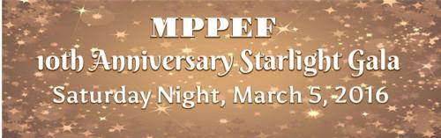
The Midland Park Public Education Foundation invites you to the…
10th Anniversary Starlight Gala
Saturday, March 5, 2016
7-11 p.m.
Macaluso’s, 161 Rea Ave. Hawthorne, NJ
Incredible Raffle Baskets/Amazing Silent Auction Items/Cash 50/50 Raffle
$100 per person
(Includes beverages *B,W,S*, dinner, dancing & fun with friends!)
We're celebrating ten years of making educational dreams come true in Midland Park Public schools!
Join us as we continue to raise money for educational grants and scholarships!
Purchase your tickets today via PayPal at www.mppef.org (password: mppefgala16)
Or fill out this form and mail check payable to:
MPPEF
PO BOX 5, Midland Park, NJ 07432
Questions? Contact Reservation Chairs:
Amy Fells, Dina Murray, Grace Torry at mppefgala@gmail.com
***************************************************************************************************
Table seating requests will be accommodated to the best of our ability. Tables seat 10-12 people.
Name: ________________________________________# of people in party:__________________
Total amount enclosed:_______________ Email (required):________________________________
Please seat me with:________________________________________________________________
All contributions are tax-deductible to the fullest extent permitted by law.

